
LORD STREET LIVING- GUIDANCE NOTE
CONSERVATION CONSIDERATIONS

Introduction:
Lord Street is traditionally the main retail high street in Southport comprised of numerous historic buildings and verandahs, many of which are listed. The quality and quantity of heritage buildings and assets in the area are cherished by residents and visitors alike and create a unique environment resulting in Lord Street being designated as a Conservation Area.
The aim of the Lord Street Living project is to encourage, where appropriate, the conversion of vacant space above and to the rear of shops into residential units. Increasing residency along Lord Street brings many socio-economic benefits to Southport town centre including improved night-time and year-round economies. Further, reuse of existing buildings is more environmentally sustainable than new build and allows improvement and enhancement of historic buildings so they can be enjoyed for years to come.
This document aims to help you think about some of the conservation requirements you need to consider prior to submitting a planning application for conversion of vacant space to residential accommodation. In brief it covers:
- The Conservation Framework
- The process to successful proposals
- Finding the Expertise
Please note that this document does not cover Housing requirements and legislation. These are covered separately in the document Residential Requirements available on the website or you can request it via the email address below.

Website: www.lordstreetliving.org
email: lordstreet.living@sefton.gov.uk

CONSERVATION FRAMEWORK

Sefton has 25 conservation areas, approximately 560 listed buildings (encompassing over 800 individual buildings), 5 Registered Historic Parks and Gardens and 13 Scheduled Monuments. These are important on a national scale as examples of their type. Well known architects and landscape designers have designed some of Sefton’s historic buildings, parks and gardens. Others are the best surviving examples of the local vernacular architecture, that is buildings built by early residents using locally available materials designed to withstand the local climate and support local industries. All of Sefton’s designated heritage is protected by the Council both for their own sake and for their cultural, historic, educational and economic value.
There are many listed buildings on Lord Street including many of the verandahs, and the historic significance of this part of Southport is offered protection through the designation of the Lord Street and Promenade Conservation Areas.

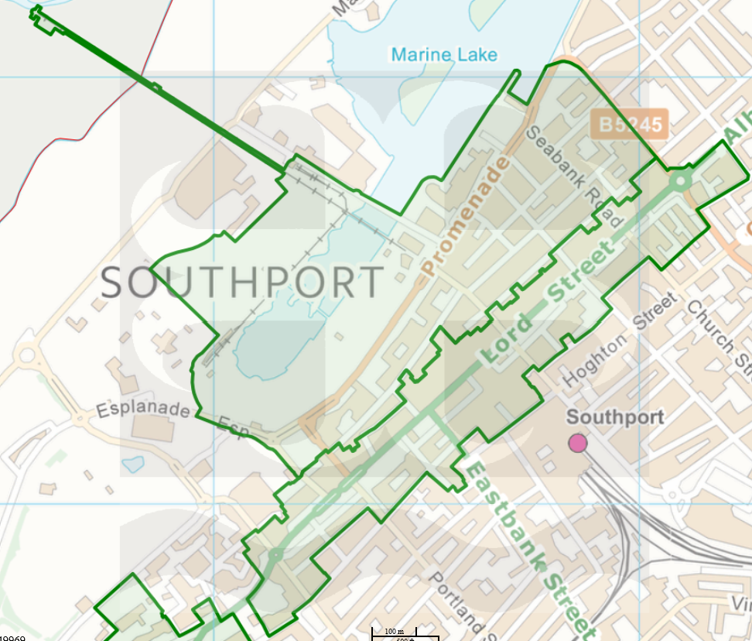
Figure 1 Map of Lord St and Promenade Conservation Areas (SMBC)

The over-arching responsibility for Sefton Council when considering planning proposals that affect heritage assets and within historic environments is to manage change in ways that protect and ideally, enhance significance. Significance is one of the guiding principles in the NPPF, defined as ‘the value of a heritage asset to this and future generations because of its heritage interest’. ‘Such interest may be archaeological, architectural, artistic or historic and can be derived from the asset’s physical presence and its setting’. (HEAN12, 2019)
The main legislation relevant for heritage assets and Conservation Area are:
Town and Country Planning Act 1990 | Sets out the planning framework and defines what development is.
Planning (Listed Buildings and Conservation Areas) Act 1990 | Provides special protection for buildings and areas of special architectural or historic interest through designation
Civic Amenities Act 1967 | Introduced the concept of conservation areas and requires local planning authorities to designate areas of special architectural or historic interest with the aim of preserving or enhancing their character or appearance.

There is other legislation that protects Parks and Gardens, Wrecks, Scheduled Monuments and Archaeological Areas.
In addition to legislation there are several policies which guide the planning authority when making decisions affecting heritage assets both designated (listed) and Non-designated (NDHA) and include:
National Planning Policy Framework (NPPF) | The NPPF (2025) is the main planning policy document all development proposals should refer to, with chapter 16 covering Heritage Assets.
Historic Environment Planning Practice Guidance (PPG15) | Provides additional information to local authorities to guide decision making in the historic environment.
Local Plan Policies – Chapter 11 key policies being: | NH9 - Heritage Assets  NH10 - Demolition or substantial harm to Designated Heritage Assets.  NH11 - Works affecting listed buildings.  NH12 - Conservation Areas.  NH15 – Development affecting Non-Designated Heritage Assets (NDHA)

Further important advice and guidance is provided by Historic England as the public body that helps identify and protect heritage. Historic England provide advice on a wide range of topics from the planning process to guidance on technical issues. Historic England Advice Note 12 (HEAN12) is the key document to understand how change is managed to heritage assets in a planning context.
To see the range of guidance and advice available visit: Current Guidance and Advice | Historic England
GOOD TO KNOW- It is a criminal offence to demolish, alter or extend a listed building without first getting consent, which will only be granted where there is no detrimental effect on a building’s character or appearance and the alterations are justified. Alterations include everything from changing glazing bars and painting the exterior to extensions, internal and external alterations and any demolition.
It is important to be aware of the different legislation and policies related to the historic environment when developing proposals for any heritage asset and to be aware of changes such as within the NPPF which has recently been reviewed by the Government. The next section will guide you through the process.

THE PROCESS TO SUCCESSFUL PROPOSALS

Many historic buildings have a different construction to modern ones and adapting them usually requires specialist knowledge to ensure the methods used and design considerations make the most of, and retain, each buildings significance both inside and out. Lord Street Living is managed by Sefton’s Conservation team, so we are the first point of contact for owners and investors looking to convert vacant space. We recommend following this process.
- MEET WITH THE LORD STREET LIVING TEAM
Owners should contact us to arrange an initial site visit to assess the suitability and potential their building has for conversion. During this first visit we will look around the vacant space, give you guidance on elements of the building which hold significance and therefore should be retained, and discuss other considerations such as access to upper floors, or separation of spaces for residential and ground floor commercial uses.
We can discuss what proposals you have in mind and whether you are intending to develop the building yourself or would like an investor to get on board. If you need an investor, we can take some photos and advertise your building on the Lord Street Living website. We won’t get involved in negotiations but can be there to offer conservation advice at any point throughout the process.

- IDENTIFY THE STATUS OF YOUR BUILDING
Understanding if your building is listed and what grade of listing it is (Grade I, II* or II) or if it’s an NDHA (Non-Designated Heritage Asset) is important for the level of information you will need to provide with your planning proposal. For example, the higher the grade of the building, the more thorough the heritage statement and accompanying information needs to be. Even if your building is not listed, it is within a Conservation Area, so you still need to refer to things like the conservation area appraisal and management plan to understand what needs to be considered in the design of your proposal, particularly external appearance and effects on setting.
GOOD TO KNOW - listing descriptions were usually written to identify the building so do not have details about all significant features. Listing includes all internal as well as external features and includes anything attached to the building or within the curtilage of the site at the time it was listed.

After the initial site meeting, you will have some ideas from the Conservation team about features that hold significance and therefore should be retained or enhanced. However, your building may also have interesting historic connections, whether to people, events or be symbolic of local or national social history so further research of the Historic Environment Record (HER) and through local and national archives will help you understand what is significant and help us to assess the application properly, so we know how any proposed changes affect that significance.
For further guidance on assessing the significance of your building please refer to Historic England Advice Note 12: Statements of Heritage Significance.
Some verandahs on Lord Street are Listed Buildings even if the building isn’t and repair or refurbishment of them should be included in planning proposals.

- GET THE RIGHT HELP
The higher the importance of the building (its grading status) the more likely you would benefit from the advice of a Conservation expert. A Conservation Accredited Architect can draw up the plans and provide the heritage and design and access statements required for your application. If the Architect is not conservation accredited, then you will need a Conservation expert to provide the heritage statement. We have provided a list of some local Accredited Conservation Architects in the next section, but you are free to use your own.
Your Architect/Agent will also be thinking about securing the services of a Building Control Officer to ensure proposals meet current standards. Sefton Council’s Building Control team can provide this service for you.
During the development of your proposal, the Conservation team will be happy to meet with you and/or your Architects to discuss significance that should be retained and find ways to overcome any queries or problems.

- SUBMIT A PRE-APPLICATION PROPOSAL
We would recommend submitting a pre-application before a full application to address planning concerns at an early stage. The Council provides a comprehensive pre-application advice service, where you can choose the level of service that you require and whether you wish to have a site meeting or MS Teams meeting to discuss your scheme. the benefits of a pre-application include:
- Identify opportunities for scheme improvements at a stage when a proposal can still be modified, which result in high quality developments.
- Reduce delays through early engagement with internal consultees and other key parties.
- Establish timescale and agree the information required upfront to reduce the time it takes to validate and process applications.
- Identify the schemes which will be supported as well as those that are unlikely to be supported, so reducing the time and fees with submitting unnecessary applications.
GOOD TO KNOW: To assist owners and developers, Sefton Planning department are currently offering a free pre-application service for properties accepted under the Lord Street Living scheme. In addition, all owners and developers can book an appointment to get free advice from a Planning Officer based in the One-Stop Shop in Cambridge Arcade.

- SUBMIT YOUR PLANNING APPLICATION
Your planning application should now have considered any suggested changes from the pre-app stage and be ready for submission via Sefton Council or the Planning Portal. Once you have your approval it is important the scheme is delivered as per the permissions and any conditions. If during delivery of the scheme unforeseen issues crop up, talk to the Planning Officer or the Conservation team so they can be addressed early. This may result in the requirement to vary the conditions, but you will be advised if this is the case.
It is important to note that all proposals will require planning permission, but if you are dealing with a listed building, you will also be required to obtain Listed Building Consent, which can be done simultaneously to your planning application.
- FOLLOW UP MEETING
Once your scheme has been developed, the conditions will need to be signed off by the Planning department. The Lord Street Living team can visit to promote your property, discuss and learn from your experience to inform future work or just to celebrate your success! We can also put you in touch with services that may be able to help such as local Estate Agents that provide a full management service.
In the next section we provide a list of accredited architects and other services that you may find useful when developing your proposal.

FINDING THE RIGHT EXPERTISE

ARCHITECTS:
As mentioned, you may want to employ a conservation accredited architect to draw up plans and complete the heritage statements or use a firm to carry out repair works on your heritage building. Below is a list of those firms known to have done this sort of work.
For the avoidance of doubt this is an unofficial list and is by no means comprehensive, and that the Council and Lord Street Living is unable to recommend any individual firm. However, it is suggested that two or three contractors be consulted either from this list or from your own in respect of the proposed works.
NEIL HUTCHINSON (CA)  Owen Ellis Architects, Stanley Hall, Edmund Street, Liverpool L3 9NG  T 0151 227 1555  nhutchinson@owenellis.co.uk  www.owenellis.co.uk | ROBERT LISTER (SCA)  Purcell, Carvers Warehouse, 77 Dale Street, Manchester M1 2HG  T 0161 300 7747  robert.lister@purcelluk.com  www.purcelluk.com
GEOFFREY LLOYD (CA)  Halsall Lloyd Partnership, 98 Duke Street, Liverpool L1 5AG  T 0151 708 8944  geoff.lloyd@hlpdesign.com  www.hlpdesign.com | RAY MAKIN (CA)  Atelier MB, Suite 1A, Amazon House, Brazil Street, Manchester  T 0161 236 0051  ray@ateliermb.co.uk  www.ateliermb.co.uk
TOM MCEVOY  Ainsley Gommon Architects, 1 Price Street, Hamilton Square,  Birkenhead, Merseyside CH41 6JN  T 0151 647 5511  aplant@ainsleygommonarchitects.co.uk  www.ainsleygommonarchitects.co.uk | LISA MCFARLANE (CA)  Seven Architecture, Oxford Place, 61 Oxford Street, Manchester M1 6EQ  T 0161 126 5655  lisa.mcfarlane@sevenarchitecture.co.uk  www.sevenarchitecture.co.uk
RICHARD ROBERTS (CA)  Cass Associates, Studio 104, The Tea Factory, 82 Wood Street,  Liverpool L1 4DQ  T 0151 707 0110 / 07904 948680  richard.roberts@cassassociates.co.uk  www.cassassociates.co.uk | ADRIAN PEARSON (SCA)  Lloyd Evans Prichard Ltd, No. 5 The Parsonage, Manchester M3 2HS  T 0161 834 6251  adrian.pearson@lep-architects.co.uk  www.lep-architects.co.uk
MICHAEL HARTLEY (SCA)  Cassidy + Ashton Group Ltd, 7 East Cliff, Preston PR1 3JE  T 01772 258356  michaelhartley@cassidyashton.co.uk  www.cassidyashton.co.uk | GARETH RICHINGS (SCA)  Purcell, Carver’s Warehouse, 77 Dale Street, Manchester M1 2HG  T 0161 300 7751  Gareth.Richings@purcelluk.com  www.purcelluk.com
BERNADETTE BONE (CA)  BB Heritage Studio, 19 Lumb Lane, Littlemoss, Manchester M43 7BU  T 07813 076325  bb@bbheritagestudio.com  www.bbheritagestudio.com | RICHMAL WIGGLESWORTH (CA)  Sheppard Robson, City Tower, Piccadilly Plaza, Manchester M1 4BT  T 0161 233 8946  Richmal.Wigglesworth@sheppardrobson.com  www.sheppardrobson.com
Chambers Conservation Ltd  Contact: Jennifer Chambers  Address: 88 Tattenhall Road, Tattenhall,  Chester, CH3 9QJ  T: 07484 133270  E: jennifer@chambersconservation.com  W: www.chambersconservation.com | Caroline Drake  Donald Insall Associates, Bridgegate House, 5 Bridge Place,  Chester CH1 1SA  T 01244 350063  caroline.drake@insall-architects.co.uk  www.insall-architects.co.uk
IAN BRIGHT (CA)  Ian Bright Architects, The Stables, King Edward Street, Macclesfield,  Cheshire SK10 1AQ  T 0161 818 2225 / 07775 688825  ib@ianbrightarchitects.com  www.ianbrightarchitects.com | Atelier MB Ltd  Contact: Ray Makin  Address: Suite 1A Amazon House,  Brazil Street, Manchester M1 3PJ  T: 0161 236 0051  E: ray@ateliermb.co.uk  W: www.ateliermb.co.uk  I: @ateliermbarchitects  Tw: @ateliermb
JENNIFER CHAMBERS (SCA)  Chambers Conservation Ltd, 88 Tattenhall Road, Tattenhall,  Chester, CH3 9QJ  T 07484 133270  jennifer@chambersconservation.com  www.chambersconservation.com | Halsall Lloyd Partnership  Contact: Geoffrey Lloyd  Address: 98 Duke Street, Liverpool L1 5AG  T: 0151 708 8944  E: geoff.lloyd@hlpdesign.com  W: www.hlpdesign.com
JAMES GIBSON (SCA)  7 Red Lane, Appleton, Warrington, Cheshire WA4 5AD  T 01925 267344  james.gibson5@btinternet.com | ROD HACKNEY (SCA)  Rod Hackney and Associates Ltd, St Peters House, Windmill Street,  Macclesfield, Cheshire SK11 7HS  T 01625 431792 / 07740 782391  rodhackney@btconnect.com
MALCOLM KNIGHT (CA)  Bernard Taylor Partnership, Elizabeth House, 486 Didsbury Road,  Heaton Mersey, Stockport SK4 3BS  T 0161 443 1221  malcolm@btparchitects.co.uk  www.btparchitects.co.uk | Anthony Grimshaw Associates LLP  Contact: Rebecca Grimshaw  Address: 6 Bridgeman Terrace, Wigan,  Greater Manchester WN1 1SX  T: 01942 245777  E: aga@anthonygrimshawassociates.co.uk  W: www.anthonygrimshawassociates.co.uk  I: @anthony_grimshaw_associates
Purcell  Contact: Damien Woolliscroft  Address: St James', 79 Oxford Street,  Manchester M1 6FQ  E: damien.woolliscroft@purcelluk.com  W: www.purcelluk.com  T: 0161 300 7747  I: @purcell.architecture | Buttress  Contact: Grant Prescott  Address: 41 Bengal Street, Manchester,  Greater Manchester M4 6AF  T: 0161 236 3303 | 07792 214689  E: contact@buttress.net  W: www.buttress.net
Paddock Johnson  Contact: Victoria Alderton  Address: Studio 2, The Lyceum, Bath St,  Port Sunlight, Wirral CH62 4UJ  E: victoria.alderton@paddockjohnson.com  W: www.paddockjohnson.com  T: 0151 643 1234  I: @paddockjohnson | Seven Architecture  Contact: Lisa MacFarlane  Address: Seven Architecture, Unit 1.3 Waulk  Mill, 51 Bengal Street, Manchester M4 6LN  T: 0161 126 5655  E: lisa.mcfarlane@sevenarchitecture.co.uk  W: www.sevenarchitecture.co.uk  Tw: @seven_arch  I: @sevenarchitecture
Kepczyk Pearce Sanderson  Contact: Duncan Sanderson  Address: 75 Wilmslow Road, Handforth,  Cheshire, SK9 3EN  T: 01625 400 103  E: duncan.sanderson@kpsarchitects.co.uk  W: www.kpsarchitects.co.uk | Francis Roberts Architects  Contact: Dominic Roberts  Address: 1 Ribblesdale Place, Preston,  Lancashire PR1 3NA  T: 01772 562 221  E: architects@francisroberts.com  W: www.francisroberts.com

If you wish, you can also search conservation accredited architects registered with RIBA (Royal Institute of British Architects) www.architecture.com which also includes useful information for working with an architect.

OTHER HERITAGE GUIDANCE:
You can find lots of guidance and technical support from other conservation groups:
IHBC – Institute of Historic Building Conservation www.ihbc.org.uk has a list of different companies offering expertise in various areas of conservation work.
Historic England – the public body that identifies heritage and helps people care for, enjoy and celebrate England’s spectacular historic environment. They have the listing information for all listed buildings and lots of technical guidance on repairs, caring for heritage and adapting historic buildings in preparation for climate change challenges. www.historicengland.org.uk

SEFTON COUNCIL SERVICES:
All planning related information including policies, supplementary planning guidance, charges, conservation and heritage information and the planning charter can be found at:
www.sefton.gov.uk/planning-building-control
Planning Services: Planning.Department@sefton.gov.uk tel: 0345 140 0845 (option 8) this is the contact for any planning related services including Building Control.
Heritage Team: Heritage.Queries@sefton.gov.uk
Lord Street Living: LordStreet.Living@sefton.gov.uk
Sefton Conservation Guidance – Sefton’s Conservation team have produced a suite of guidance documents to assist owners to maintain buildings and verandahs and improve energy efficiency in historic buildings. The advisory leaflets and management plans for each conservation area are also available to view on the Conservation and heritage page on Sefton Councils website (click link below)
Listed Buildings
